**APPENDIX –C**

**HELP DOCUMENT**

Step 1: install the visual studio 2015

Step 2: install the SQL server 2014

Step 3: To copy the project code in drive D

Step 4: Open the SQL server 2014 and enter password is 123. After click Connect button.

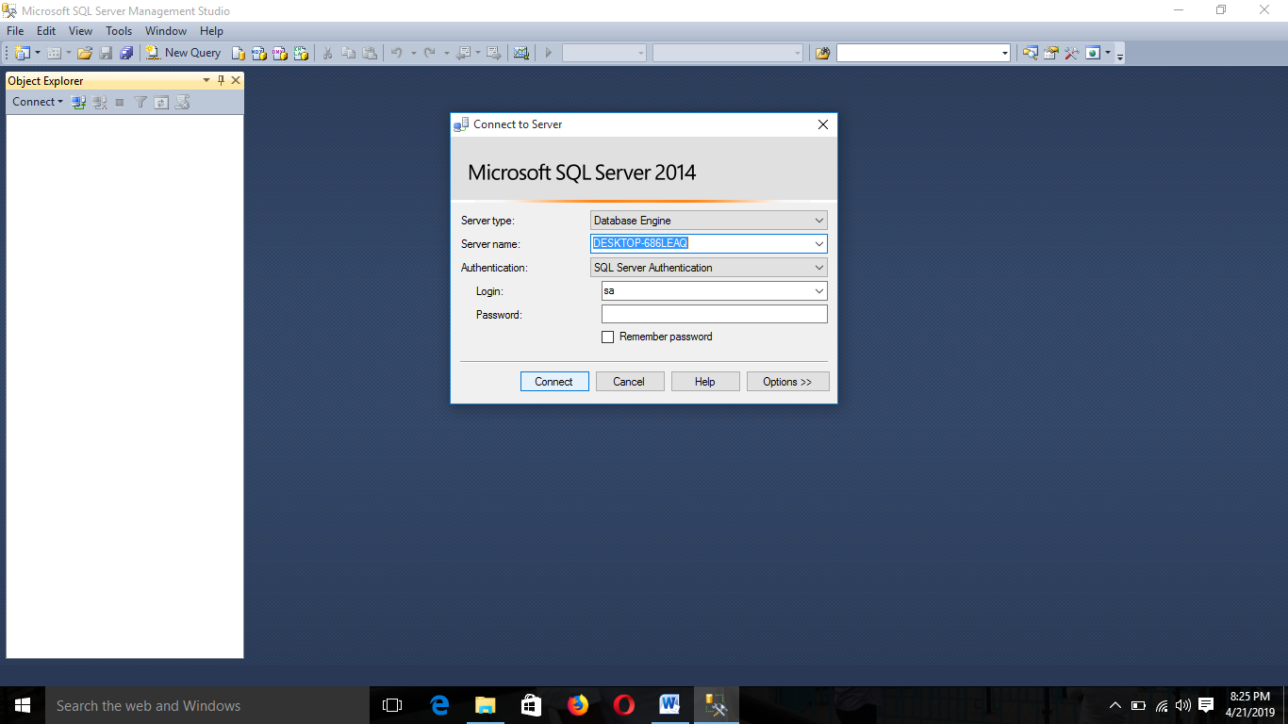

Step 5: Open the visual studio 2015

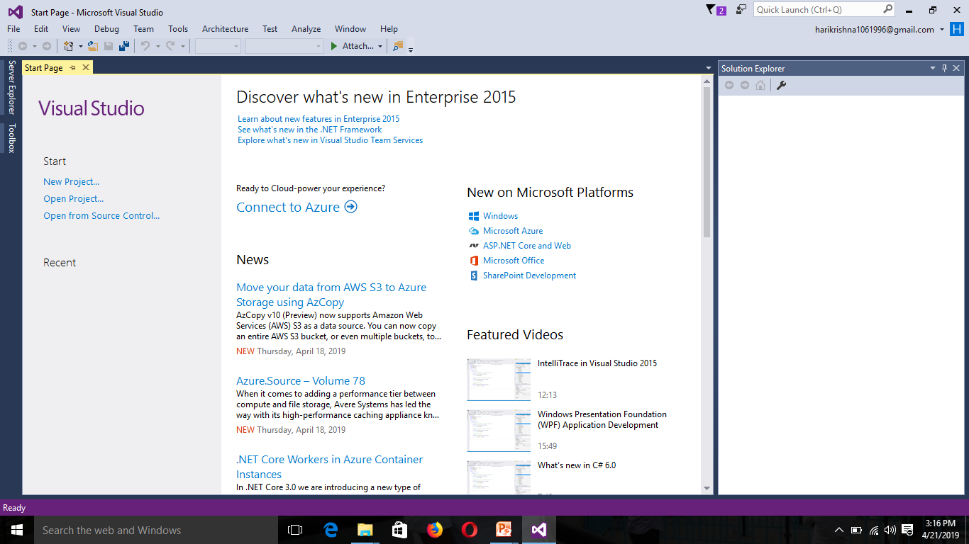

Step 6: select file option Open web site

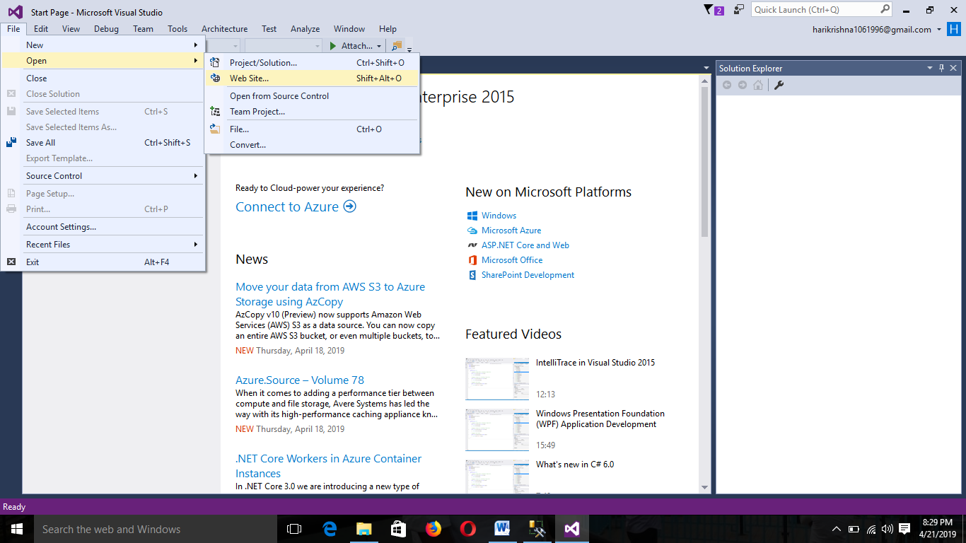

Step 7: Select the folder HPPQ in Drive D and to click open button

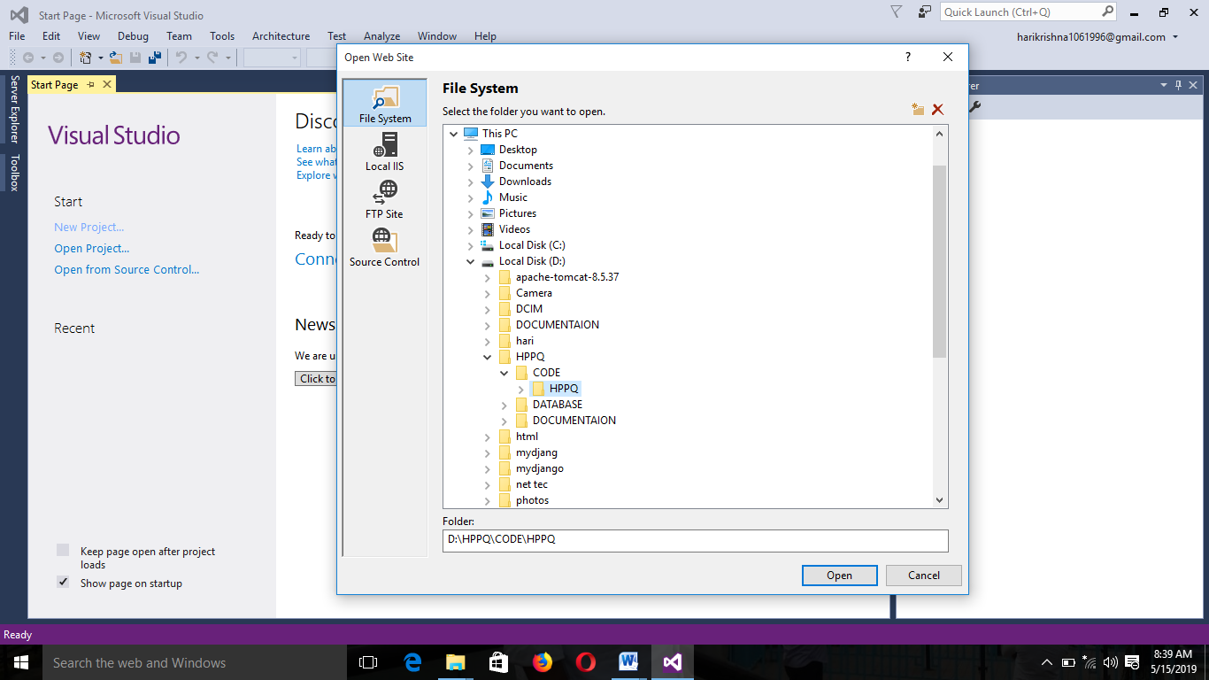

Step8: Select Default2.apx file and right click , to select default browser is chrome , click the browse button.

